# [**How Mariska Hargitay Wants Olivia Benson's Law & Order: SVU Story to End**](https://www.eonline.com/news/1347087/how-mariska-hargitay-wants-olivia-benson-s-lessigreaterlaw-and-order:-svulessigreater-story-to-end?cmpid=social&content=organic&medium=link-post&source=twitter-enews)

## After nearly 25 years of playing Captain Olivia Benson on *Law & Order: SVU*, Mariska Hargitay revealed she has the perfect ending in mind for her iconic character on the NBC series.

**By** [**ALEX ROSS**](https://www.eonline.com/authors/alex-ross)**,** [**PAIGE STROUT**](https://www.eonline.com/authors/paige-strout) **SEP 20, 2022 3:24 PMTAGS**

**Watch: Mariska Hargitay & Sam Waterson Talk "Law & Order" Reboot Differences**

All good things must come to an end, including [**Mariska Hargitay**](https://www.eonline.com/news/mariska_hargitay)'s time on [***Law & Order: Special Victims Unit***](https://www.eonline.com/news/law_and_order_special_victims_unit).

The actress has spent almost 25 years playing Captain Olivia Benson on the [**NBC**](https://www.eonline.com/news/nbc) crime drama, and her character has become nothing less than iconic ([**Taylor Swift**](https://www.eonline.com/news/taylor_swift) even named [**one of her cats**](https://www.eonline.com/news/1047262/inside-the-glamorous-life-of-taylor-swift-s-cats) after her). [**In 2018**](https://www.eonline.com/news/970627/mariska-hargitay-already-has-her-ideal-ending-for-law-and-order-svu-s-benson), the star teased her character's ideal ending to E! News, but she didn't reveal what it was...until now.

"I hope that she can get to a point where she feels like she's done enough service and it's time to rest and be and see the best that life has to offer," she exclusively told E! News on Sept. 19 at the show's season 24 premiere in NYC, "because she's spent so much time in the darkest of what life has to offer."

As for what that would entail? "I think it would be sharing her life with someone," said Hargitay, "and being able to focus totally on the joys of motherhood." Olivia is the adoptive mother of Noah Porter-Benson (**Ryan Buggle**), the son of Ellie Porter (**Emma Greenwell**) and Johnny Drake (**Charles Halford**).

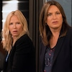

[**PHOTOS**](https://www.eonline.com/photos/33357/law-order-svu-partners-ranked-from-worst-to-best)

[***Law & Order: SVU* Partners, Ranked From Worst to Best**](https://www.eonline.com/photos/33357/law-order-svu-partners-ranked-from-worst-to-best)

The actress doesn't know who the "someone" Olivia could end up with is, telling E! News, "I don't know. Let's see what pops up!"

However, her character was in a *very* slow-burn, [**will they/won't they relationship**](https://www.eonline.com/news/1262012/why-were-not-ok-with-stabler-confessing-his-love-to-benson-on-law-order) with her former partner in crime, Elliot Stabler ([**Christopher Meloni**](https://www.eonline.com/news/christopher_meloni)), for years before he made the move to [***Law & Order: Organized Crime***](https://www.eonline.com/news/1328659/christopher-meloni-and-denis-leary-get-feisty-in-law-order-organized-crime-sneak-peek) in 2021.

Perhaps fans will finally get the romance they've been waiting for before Olivia's eventual goodbye on the series.

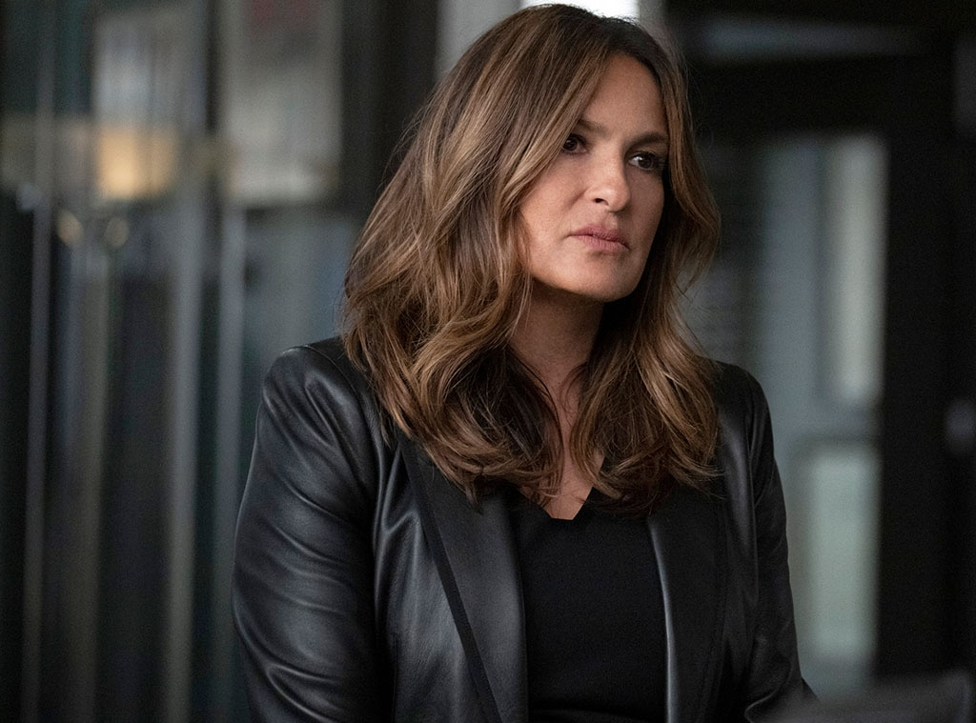Virginia Sherwood/NBC

The role is one that Hargitay will carry with her forever, as she has picked up several lessons from the Captain over the years that she'll apply to her real life.

"I would say learning to tolerate our feelings and knowing that we can get over anything, that they pass, and then we're stronger because of it," she said. "It's just about accessing our strength. I think that Olivia is such a badass who's grown into her power. And that is our journey for all of us women."

*Law & Order: SVU* season 24 premieres Thursday, Sept. 22, at 9 p.m. on NBC.

(E! and NBC are both part of the NBCUniversal family.)